IT6425_Programming Lab Sheet 02
(Chapter Three, Java How to Program)

This Lab aims to help you practice basic programming concepts from chapter three of your text book, including important features of Java to create your own classes & methods, create objects of your own classes and call methods of those objects to perform actions. Your task for this lab is to complete following exercises from chapter three:

Task One Exercise – Create a new project called Account.java with the following variables and methods included as shown in Figure1: Account Class.
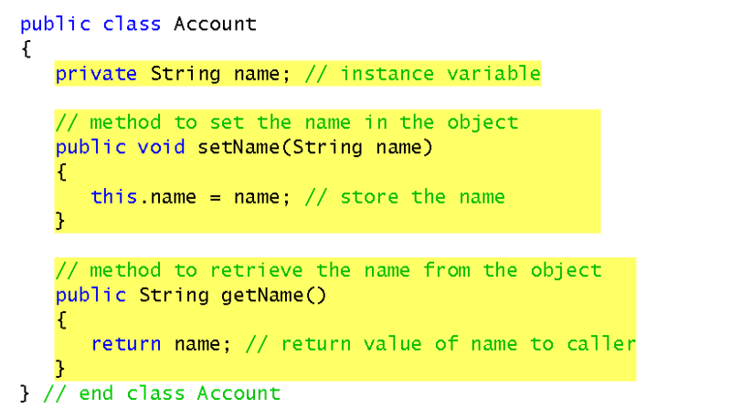
Figure 1: Account Class

Task Two Exercise – Add another class called AccountTest as shown in Figure 2: AccountTest Class.

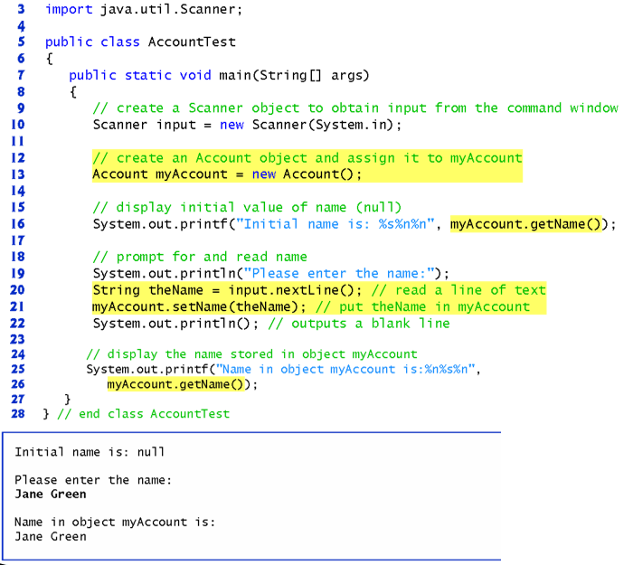
Figure 2: AccountTest Class

Task Three Exercise 3.11 (Modified Account Class)
Modify class account (Fig. 3.8) to provide a method called Withdraw that withdraws money from and account. Ensure that the withdrawal amount does not exceed the account’s balance. If it does, the balance should be left unchanged and the methods should print a message indicating “Withdrawal amount exceeded account balance”. Modify class AccountTest (Fig 30.9) to test methods withdraw.

Task Four Exercise 3.11 (Class Diagram)
Construct a UML class diagram for Account.java

Task Five Exercise 3.12 (Class Petrol Purchase)
Create a class called PetrolPurchase to represent information about the petrol you purchase. The class should include five pieces of information in the form if instance variables – the station’s location (String), type of petrol (String), the quantity (int) of the purchase in litres, the price per litre (double) and the percentage discount (double). Your class should have a constructor that initializes the five instance variables. Provide a set and get method for each instance variable. In addition, provide a method named getPurchaseAmount() that calculates the net purchase amount (Multiply the quantity by the price per litre) minus the discount, then returns the net amount you had to pay as a double value. Write an application class named petrol that tests and demonstrates the capabilities of class PetrolPurchase.

Task Six Exercise 3.12 (Class Diagram)
Construct a UML class diagram for PetrolPurchase.java

Task Seven Exercise 3.13 (Class Car)
Create a class called Car that includes three instance variables – a model (type String), a year (type String), and a price (double). Provide a constructor that initializes the three instance variables. Provide a set and get method for each instance variable. If the price is not positive, do not set its value. Write a test application named CarTest that demonstrates Cars capabilities. Create two Car objects that display each objects price. Then apply a 5% discount on the price of the first car and a 7% discount on the price of the second car. Display each cars price again.

Task Eight Exercise 3.13 (Class Diagram)
Construct a UML class diagram for Cars.java

UML DIAGRAMS

Account |  | PetrolPurchase
String name  double balance  double depositAmount  double withdrawAmount |  | String station  String petrolType  int pLitre  double pricePerLitre  double percentDiscount  double total  double quantity
constructor Account(String , double)  deposit(depositAmount double)  withdraw(withdrawAmount double)  getBalance()String  setName(name string)  getName() String |  | constructor PetrolPurchase (String,  String, Int, double, double, double,double  ) constructor  getStation() method  getType() method  getLitre() method  getPricePerLitre() method  getPercentDiscount() method  getTotal() method  getPurchaseAmount() method

Car
String model
String year
double price

constructor Car(String, string, double)
getPrice() method
setModel() method
getModel() method
setYear() method
getYear() method

